Operating Systems - Linux
__________________________________________________

Practical 3

Last week you looked at a number of ways to get help under Linux – using the man, info and whatis commands. You also saw a few other useful commands such as cal and date. This week you will continue your examination of the Linux OS. In particular, you will examine how to navigate the Linux file system at the command line and manipulate files and folders in different ways.

Once you have logged on to Linux and issued the startx command to move into the GNOME desktop environment, you should launch the terminal window using the shortcut you created for it on the desktop last week. Recall that this terminal window (or xterm as it is sometimes called) runs the bash shell within it and this shell is effectively your means to “talk” to the Linux kernel and get it to carry out various tasks on your behalf.

File Types in LInux

Linux differs from Windows in one fundamental way – like UNIX, it considers everything on the system to be either a file or a process. Therefore devices such as hard disks and memory sticks, that are traditionally thought of being “hardware” devices rather than “software” files, on a Windows system, are treated just like files on Linux.

Most files on a Linux system are just referred to as regular files. These include text files and executables. Other types of Linux file include:

directories – files that are lists of other files
special files – these files are used for input and output and most special files are contained in the /dev directory of the Linux system
links – a mechanism that allows a file to appear in multiple parts of the system's file tree.
sockets – a mechanism similar to TCP/IP sockets that allows inter-process networking communications
named pipes – similar to sockets in that they allow IPC without using network socket semantics

Exercise 1: Checking to see where you currently are in the file system using pwd

You are using what is called the Bash shell for your work today. We will talk more about shells later – for now it is enough for you to know that a shell is capable of interpreting the command you supply at its prompt. The Bash shell is regarded as being one of the best for interactive type work. Remember that you can normally tell immediately what directory you are currently in when using the Bash shell via the terminal window prompt. But it doesn’t tell you what the absolute path is to this directory. Worse still, for some other shells, no directory information whatsoever may be transparently available by default and in order to find out the absolute path to the current working directory you’ll need to type:

pwd

which prints (displays) the current working directory to the screen.

What is the current (default) working directory?

/home2/t00152975

Exercise 2: Display files and folders (directories) using ls

At the prompt type

ls

This is one of the most important Linux commands of all since it allows you view a list of all the (non-hidden) files and subdirectories in your current working directory (cwd).

Your current working directory at the moment should be your home directory and when you log into Linux you will always, by default, be initially brought into your home directory (e.g. /home2/t00012345). It is your personal location on the Linux system and is the place where you can save your work.

Exercise 3: Display lots of information on files and folders (directories) using ls -a -l

Like most Linux commands, ls has a number of options (switches) associated with it, which can be used for more specific listings of files/directories.

e.g. if you type

ls –a -l

at the prompt, you will get a long (-l option) listing of all (-a option) files which means that what are called hidden files (often system files created automatically at the time your account is created) will also be displayed. You can always recognise hidden files in Linux since they begin with a full stop e.g. .bash_history

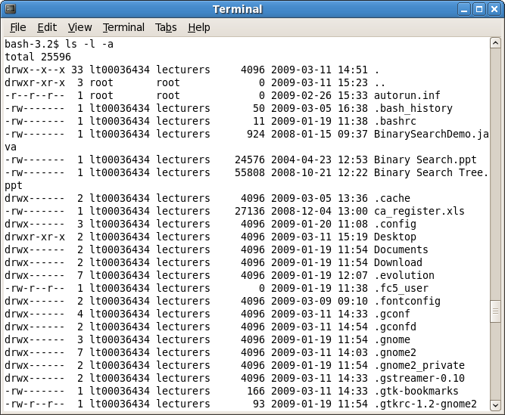

Referring to the line in the screenshot above:

drwxr-xr-x 2 lt000036434 lecturers 4096 2009-03-11 13:05 Desktop

the long-listing means that you get a lot of extra information, from left to right these are:

file type, indicated by the first d above
permission modes on the files/directories, indicted by the rwxr-xr-x above
number of links to the file, indicated by the 2 above
file owner, indicated by the lt00036434
group owner, lecturers above
size in bytes, indicated by the 4096
time of last modification, indicated by the date and time given 2009 etc
file name, indicated by the Desktop (a directory)

file type symbols

Each file has a symbol to indicate its type. These are:

- for regular files
d for directories
l for links
c for special files
s for sockets
p for pipes

So in the screenshot above you can see that my home directory, and yours also most likely, only contains regular files and directories.

permission modes

Any file you create yourself, you are guaranteed to be the owner of and the group you belong to depends on how the system administrator has things set up (you could be part of the CPMM100, CPGD100 or CPSW100 group for example). Permissions are a security feature for files and such permission modes also exist under Windows XP. Permission modes in Linux consist of 3 bits of information for each of 3 groups (owner, group and others) in that order, making 9 bits of information in total. Each 3 bits can have rwx
r allow read access
w allow write access
x allow execution of file
– signifying that that access is not allowed.

In my case above you can read the permission modes on the file called .bash_history as follows:

rw-------
“This file can be read or written (modified/moved/deleted) by the owner of the file (lt00036434), it cannot be executed by the owner (-). The file cannot be read/written/executed by users in the same group as the owner or by others.”

With reference to the file .gtkrc-1.2-gnome2 in the screenshot earlier, answer the following questions:

- What type of file is this? Regular file
- How many links does this file have? 1
- What is the size of this file in bytes? 93
- Who owns this file? lt00036434
- Who is the group owner of this file?
- What permissions does the owner of the file have? lecturers
- What permissions do all others have on the file? Owner can read & write, group & others can read only. -rw-r--r--
- What permissions does the group have on the file? Read only

Naturally it is possible to alter permission modes on a particular file and we shall look at this in a later practical.

N.B. multiple options can be combined so that ls –a –l is equivalent to ls –al. Prove this to yourself now.

Exercise 4: Changing into a directory using cd

The command for changing into a directory is exactly the same in Linux as it is for DOS and is one of the more important Linux commands. In order to go into the Desktop directory, which should exist in your home directory /home2/t00012345 (where you are currently by default) you just type

cd Desktop

You should see that just before the $ prompt,there has been a change from ~ , which is shorthand for “the home directory”, to “Desktop”.

Now use the command ls -a to list the files and directories in this directory. Check that the entries that are listed refer to something on the desktop. Some of these entries refer to the shortcuts that you have created on your desktop for the terminal and OpenOffice Writer application. However, you should also see references to . and ..

. means the current working directory (cwd) – it is just shorthand for it. This notation is very handy when you need, for example, to copy the contents of another directory to the directory you currently find yourself in (i.e. the cwd). Instead of having to supply the possibly long-winded absolute path to the cwd you can just supply . to refer to it. You will see this shorthand notation for cwd used later.

So, what do you think the effect of the following command would be?

cd .

Try it out to see if you are right. Write down what you think is going on here.
Terminal stays at the same location i.e. [t00152975@labpc ~]$

.. means the directory that lies immediately above the cwd (often called the parent directory). Again this is just shorthand notation to refer to that directory

So, what do you think the effect of the following command will be?

cd ..

Try it out to see if you are right. Write down what you think is going on here.
It takes me to the home directory. [t00152975@labpc home2]$

Exercise 5: The Linux File System

The file system in Linux appears like a tree structure. Depending on the exact installation, certain directories may be added or removed but your file system will definitely look similar to the graphic below. The top of the tree is the root directory, indicated by the / symbol.

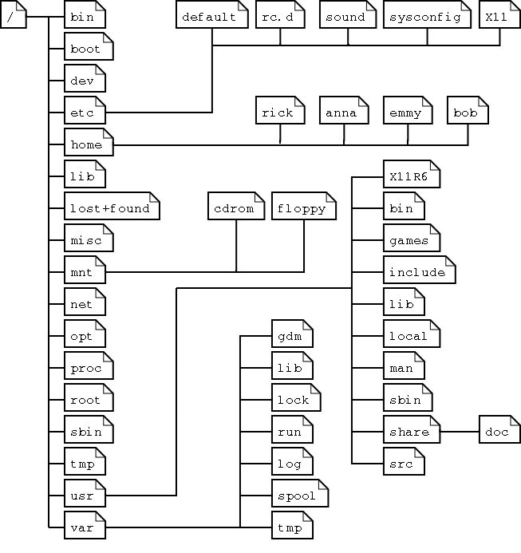

You should now change into the root directory as follows:

cd /

You should now list all the files and directories in your root directory using ls.

There should be about 20 directories listed (how can you tell they are directories?). Notice that there are often no regular files or other file types listed in the root directory.

Name 3 directories that you have found in the / directory

1. bin
2. boot
3. export

The directories directly beneath the root directory contain certain types of information and break the overall file system into well-defined logical groupings. Some of these directories and what they contain are as follows:

/bin – common programs (binaries) shared by the system, administrator and regular users.
/boot – the startup files and the kernel itself, vmlinuz, Also GRUB boot loader data.
/dev – references to all the peripheral devices and disks
/etc – the most system configuration files, similar to “Control Panel” in Windows
/home – the home directories of the regular users (yours is actually in /home2 in ITT)
/lib – library files, including files for various programs needed by the system and users
/mnt – traditionally the standard mount point for external file systems such as memory sticks and external hard drives but in your case these are located under /media.
/net – the standard mount point for remote (network) file systems
/opt – often used to store 3rd party software
/proc – a virtual file system containing various information about system resources and processes
/root – the home directory of the administrative user root
/sbin – programs used by the system and administrator
/usr – programs, libraries and documentation used by user-related programs
/var – storage for temporary files created by users e.g. Log files, mail queue, temporary storage of files downloaded from the Internet, keep a temporary image of a CD before burning it.

Using the cd command on its own with no arguments will change you into your home directory from whatever directory you are currently working from. Try this now by typing

cd

The presence of the ~ before the $ prompt confirms that you are back to your home directory.

Exercise 6: Creating a new directory using mkdir

mkdir allows you to create a new directory. Assuming you are in your home directory, create a directory called yourname (so if your name is Betty Brown create the directory BettyBrown etc) as follows:

So type something like

mkdir BettyBrown

This creates a new directory in your home directory in this case.

Now check that this directory has definitely been created. What command did you use for this check? ls -al

You should now change into this newly created directory and then create a new directory called OSlabstuff. So now you should have something similar to the following directory structure:

/
home2
t000*****
BettyBrown
OSlabstuff

Once you have the Oslabstuff directory created, check to ensure it is definitely there and then change into it.

Exercise 7: Relative and Absolute Path Names

Now you should navigate your way to the Desktop folder in your home directory as follows:

cd ../../Desktop

The use of the .. symbol here to refer to the parent directory is an example of using a relative path. So ../../ will change you into the directory that lies 2 directories above the current working directory (OSlabstuff), i.e. your home directory. The Desktop directory is located within this directory so the command is valid.

It would also have been possible to navigate your way to the Desktop folder directly using an absolute path as follows:

cd /home2/t00012345/Desktop

Absolute paths always begin at the root directory(/) whereas relative paths do not.

Exercise 8: Examining the contents of a file using cat

I have put a .txt version of this document Linux_lab3.txt in the same folder as this document. Copy that to the desktop – just drag it there.

Assuming you are now located in your Desktop folder, you should now attempt to view the contents of the file in there that begins with the word “Linux”. Do this by typing:

cat Linux*

and you should see the text within the file Linux_lab3.txt displayed to the screen. You may notice that this command displays all the output of the file in one “lump” and you may have missed the start of the file, which you can only access now by using the scroll-bar. However, if you were working at the console, this would not be possible.

Notice here also that I used the wildcard character * in order to access the file I was after. In fact, if I really wanted to in this case I could have just used the command cat L* since there is no other file in the Desktop folder that begins with a 'L'. Wildcards are very useful at the command-line, especially when you need to refer to long-winded file names.

Exercise 9: Examining the contents of a file using more

This is another command that allows you to view the contents of a file but instead of displaying all the output of the file in one “lump”, this command gives you the output page by page, which is an improvement on cat. You can just hit the spacebar to move on to the next page or return to move on to the next line, with q to quit. However, the user does lack the ability to “page up”, should they wish to see a previous page. Use the command now on the same file by typing

more L*

Exercise 10: Examining the contents of a file using less

This command is similar to more in that it displays the output of the file page by page but is an improvement on it in that it allows you to “page up”. Use the command now on the same file by typing

less L*

Exercise 11: Command and File Completion using tabs

Similar to using wildcards, it is very handy to have a utility that will complete commands or filenames for you. To see this in action change into the root directory now i.e. /

Now type in the following

cd s

When you hit the tab key here nothing happens, indicating that there must be more than one folder in this location that begins with 's'. When you hit tab again you should now be presented with all the folders that begin with 's'. In order to select the selinux folder from the list, for example, you can now just type

cd se

and then press tab just once. When you do this you should see that it will complete the line for you as follows, saving you from having to type out the 'linux' part.

cd selinux/

and you can then just hit return to change into that directory.

This command is especially useful where the file names involved are long.

This technique also works with commands. Try it as follows by typing

ls

and then pressing tab tab

Doing this will list all the commands found in your so-called PATH that begin with 'ls'. More about PATH later.

Exercise 12: Clearing the screen using clear

It is useful to be able to clear the terminal window from time to time so that you have plenty of space to work with. Just type

clear

to do this.

Exercise 13: Deleting a file using rm

It is easy to delete files in Linux, perhaps too easy at times! Once a file has been officially deleted it cannot be recovered so beware! The Trash utility only exists for items that you “Move to Trash” using an application like the File Browser and operates like the Windows “Recycle Bin”. In these cases the files still exist and are simply being moved to another location on the file system. If you delete something at the command line its gone!

Delete the file called Linux_lab3.txt that you copied to the desktop recently as follows:

First check that the current directory is /home2/t00012345/Desktop. If not change to that directory.

N.B. There is an interactive (-i ) option associated with the rm command and it is useful to use this since you will be asked to confirm that you wish to delete certain file(s) before it will do so.

rm -i Linux_lab3.txt

If you wish to remove the file just type 'y', otherwise 'n'. Often the interactive option is already associated (aliased) with the rm command. This association means that even if you type just plain rm, it will actually run as rm –i which is a good safety feature and can avoid lots of heartache! At this stage check to see if the file has been successfully deleted.

You can see what aliases exist by typing alias.
You can create an alias as follows: alias cl=clear
You can remove an alias as follows: unalias cl
You can create an alias for rm as follows: alias rm=“rm -i”

Exercise 15: Closing out of the terminal window using exit

When you're ready to close the terminal window, type the command

exit

This will exit you from the terminal window you are in. In OS terms this command has the effect of terminating the bash shell process that had been running in the current window and closing that window. But note that this is only one process and quitting it will not close down the OS on its own.

Exercise 16: Unmounting Devices, Logging Out and Shutting Down

Before you log off it is good practice to close all open windows and to unmount any devices such as memory sticks that you have attached to the system. To unmount a device simply right-click its icon on the desktop and select “Unmount Volume”. Doing this helps to prevent possible data loss and makes the shutting down process cleaner.

Now, to log off simply go to System->Log Out t00012345. Doing this will log you off, save all your session settings, and take you back to the console but the system will still remain operational.

In order to shut the system down and reboot, you need to hit ALT+CTRL+DEL at the console. This will begin the shutdown process and reboot the machine.

